**Concurrent Non-Blocking Priority Queue Implementation**

CS 550 Advanced Operating System

**Pradyot Mayank (A20405826)**

**Nilesh Jorwar (A20405042)**

**Output**

**Step 1**: Enter the number of Concurrent Clients to run in “config.properties” file.

**Step 2**: Run the server from Command Prompt using batch File.

**Step 3**: Run the Concurrent Clients from same or multiple machines as follows.

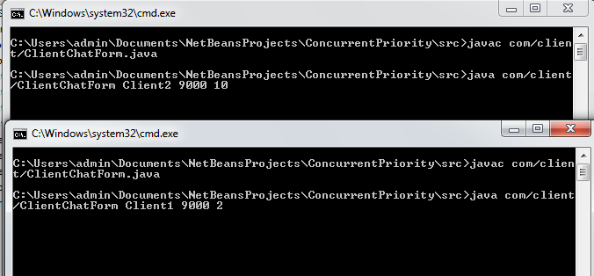

**Step 3**: Interact with the server by sending the message at the same time.

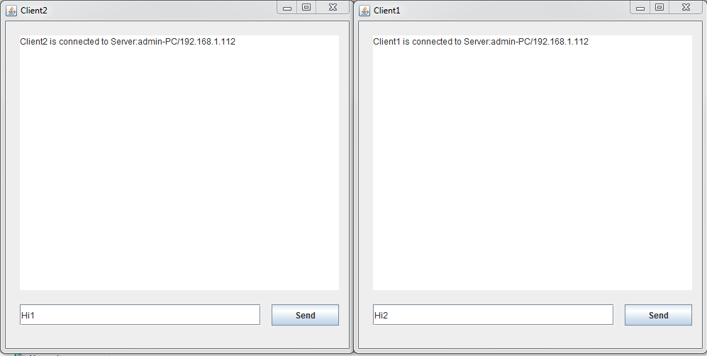

**Step 4**: Look for the server status for the sorted clients as per their priority.

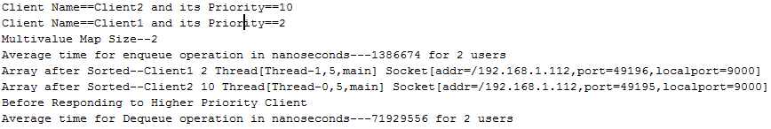

**Step 5**: Send the response to higher priority Client from the Server.

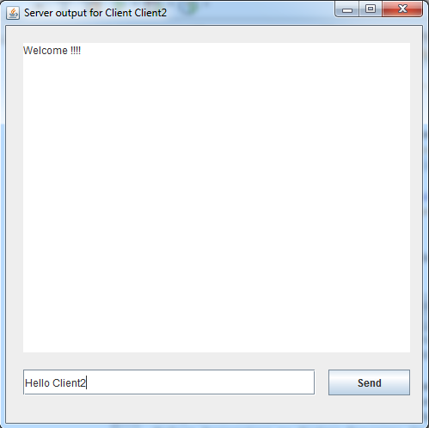

**Step 6**: Check if the higher priority Clients gets the response from the Server.

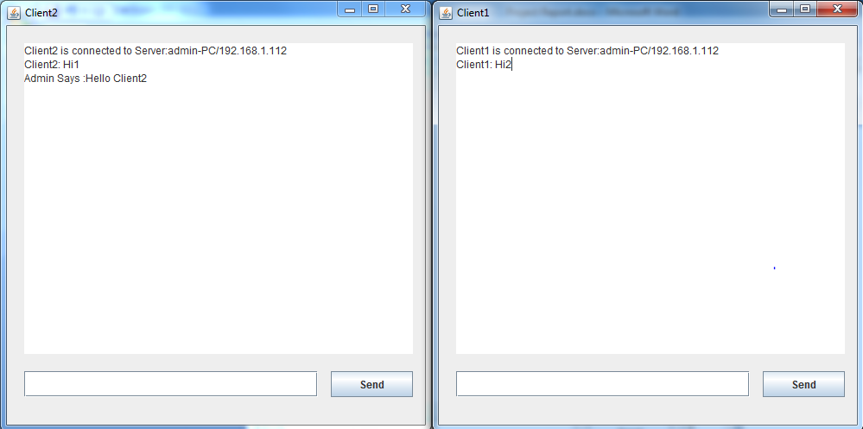

**Step 7**: Repeat above scenario from the step one for the given set of number of concurrent clients.